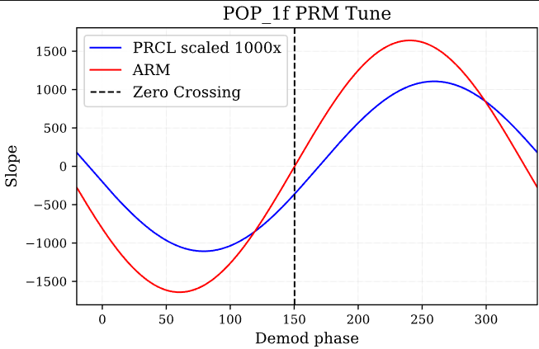

Max slope [259.19839679]

Stored 'refl_1f_PRM' (ndarray)

Max slope [240.44088176]

Stored 'refl_1f_PRM' (ndarray)

index no. of zeros [236 485]

First Zero crossing 150.26052104208418

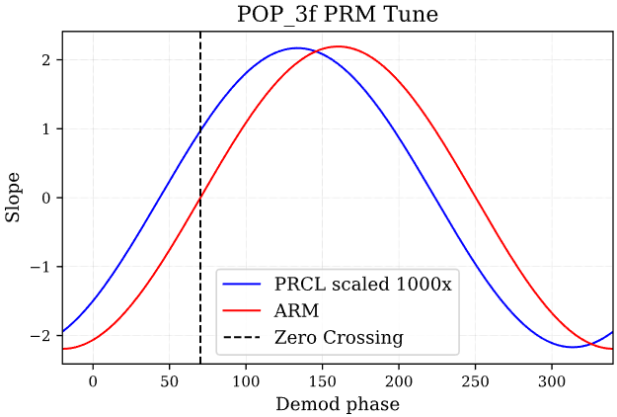

Max slope [133.66733467]

Stored 'refl_1f_PRM' (ndarray)

Max slope [160.36072144]

Stored 'refl_1f_PRM' (ndarray)

index no. of zeros [125 374]

First Zero crossing 70.1803607214429

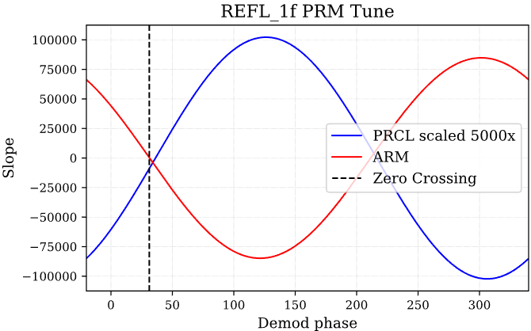

Max slope [126.45290581]

Stored 'refl_1f_PRM' (ndarray)

Max slope [301.76352705]

Stored 'refl_1f_PRM' (ndarray)

index no. of zeros [ 71 320]

First Zero crossing 31.22244488977956

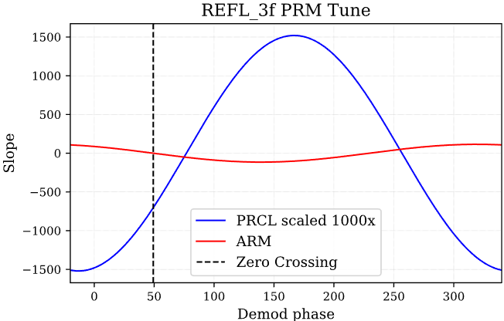

Max slope [166.85370741]

Stored 'refl_1f_PRM' (ndarray)

Max slope [319.07815631]

Stored 'refl_1f_PRM' (ndarray)

index no. of zeros [ 96 345]

First Zero crossing 49.25851703406815